The Promise
A century ago Rogljevo was incredibly prosperous for a remote village in far eastern corners of Serbia. The wines of Rogljevo were to be found at exhibitions in Bordeaux and Paris. But today this region is poor and deserted. Suddenly a French family moved in to grow grapes and produce wine. They believe they have discovered a promised land, one of the top five wine regions in Europe. Their arrival sparked high hopes with some villagers - and great resistance and mistrust with others. Can Rogljevo yet again live out of its wine?

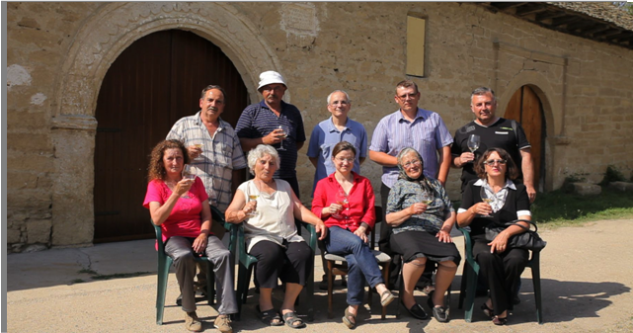
Trailer: https://www.youtube.com/watch?v=I2zroCK38vQ

The Promise is a character driven feature documentary. In a sort of “cinema verité” style follows an extraordinary experience of a French family who moved in a remote village of Rogljevo in Serbia to make wine.
Protagonists of this film, Europeans from two opposite sides of the continent, have come together in a sleepy village to try starting something new together.The French promised to revive the ancient wine glory of a forgotten region, but clash of cultures and mentalities puts that goal in question.
A century ago Rogljevo was incredibly prosperous for a remote village in far eastern corners of Serbia. The wines of Rogljevo were to be found at exhibitions in Bordeaux and Paris. But today this region is poor and deserted. Young people have left and the older struggle to make their ends meet. Suddenly a French family moved in to grow grapes and produce wine. They believe they have discovered a promised land, one of the top five wine regions in Europe. Their arrival sparked high hopes with some villagers - and great resistance and mistrust with others.
“The arrival of the French exposed some existential questions for this region, says Dusan Gajic, producer and author of the film. “The whole culture built around ancient winemaking tradition is at the edge of disappearing. Possibly the best wine terroir in the Balkans and one of the best terroirs in Europe lies today in ruins! This is a sad, striking paradox addressed by our documentary”
“I hope this documentary will be able to inspire people and launch a debate about how to revive this region and wake up the Sleeping Beauty, says Zeljko Mirkovic, producer and director of the film. It is symbolic story about our region in a wider sense: a place where great potentials often fail to realize”
Wine cellars from Rogljevo and other places in the region have been inscribed in the tentative list of UNESCO world heritage sites. Despite such recognition, the place risks becoming an empty, lifeless museum, without people who would build on its tradition and potential.
Can this forgotten treasure be revived? Can people like Cyrille and Estelle turn the tide? Or much more is needed than one passionate couple?
The Promise documentary is supported by Film Center Serbia and Creative Europe fund of the EU.

Producers Zeljko Mirkovic,Dusan Gajic
Production Optimistic film and SEETV
Director Zeljko Mirkovic
Author Dusan Gajic
Script Zeljko Mirkovic , Dusan Gajic
Editor Pavle Nikic
DoP Miodrag Trajkovic, Nikola Majdak
Music Dejan Ilijic, Aleksandar Stevanovic
Duration 56 min. and 74 min

